2021 Youth as Partners in Civic Leadership Conference

Friday, October 22nd
1:00-5:00: Arrival & Welcome Activities- Get Checked In & Settled In; Camp Turning Rivers will have recreational activities available
5:00pm-5:30pm: Adult Leaders Orientation/Meeting
6:00-7:00: Dinner
7:15-7:45: Keynote Speaker(s)-TBD
8:15-9:30: Examining our Worldview Activity – Led by End Abuse Wisconsin
9:30-10:00: Roundtables
10:00-11:00: Cabin Talks- Setting the Norms of the cabins
11:00-12:00 Cabin Time & Lights Out
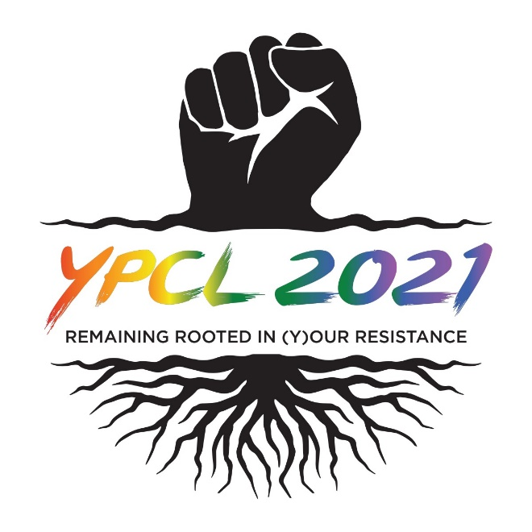

Saturday, October 23rd
8:00-9:00: Breakfast & Morning assembly- Review the day ahead
9:15-11:45: Workshops Round 1 (topics will be announced soon!)
10:15-10:45: Mindfulness break – Relaxation in cabins
10:45-11:45: Workshops Round 2
12:00-1:00: Lunch
1:00-2:00: Rec Time #1- Choose an activity
2:15-3:15: Rec Time #2- Choose an activity
3:30-5:00: Action Planning- Work within your groups on projects in your youth groups.
5:10-6:00: Advocacy Roundtable
6:00-7:00: Dinner
7:00-7:30: Talent Show Preparation- Relax in cabins & prepare for the talent show
7:30-9:00: Talent Show
9:00-11:00: Recreation Time
11:00-12:00 Cabin Time & Lights Out
Sunday, November 10th
7:00-8:00: Clean & Move out of cabins
8:30-9:30: Morning Assembly- Action plan presentations, Capstone Panel Discussion, and YPCL Planning Committee Selection
10:00-11:00: Brunch
11:00-11:30: Closing assembly- Slideshow recap of YPCL 2019 & Goodbye/depart

WORKSHOP TITLES COMING SOON!
